



ПРАЗДНИК-КОНКУРС "ST. VALENTINE'S DAY"

My dear friends, we've gathered here today to celebrate St. Valentine's Day! We've got two teams, and we shall see which team knows more about the holiday. Here are some activities for you.

1. Here are two hearts with many words on them. Which words can be connected with the holiday? Your task is to put a circle around these words when you find them in the big heart. You may start now!

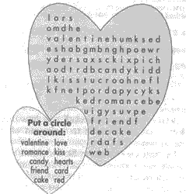

2. Well, we are speaking about love, but what do you think love is like? Now you art to answer this question! Please, continue the phrase "Love is...".



3. Now I see you know what love is, but what well-known lovers pairs can you name? (Команды получают сердечки, где написано имя одного из влюбленных, они должны назвать пару.)

Juliet & .......

Desdemona & ......

.... & Adam

........ & Admiral Nelson

Captain Grey & .....

Cinderella & .....

|  |
| --- |
|  |

....... & Hamlet

......r & Margaret

4. But sometimes we can't just talk about love, we must show it! So, try to pantomime these words to another team so that they can name them. (Команды получают сердечки со следующими словами, которые они должны пантомимой показать другой команде.)

a heart

a flower

a kiss

love

a guitar

a letter



5. And now let's talk again! You should say these tongue twisters as quick and as well as you can!

-  Merry Mary marries Marty on Monday.

-  I miss my Swiss Miss. My Swiss Miss misses me.

6I. And now we shall see how many words you will be able to make out of this one. Honeymoon.

7. Well, don't you think that it's time to talk about your love? For this task we need a boy from one team and a girl from the other. And the other way round. But the main task is for boys. My dear boys, take these hearts and you'll have some minutes to think of what you'll say to your sweethearts!

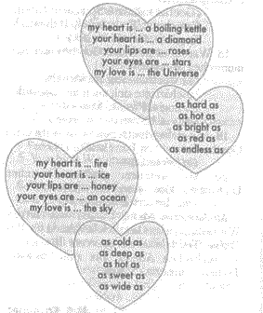

(Оценивается правильность речи и артистичность.)

8. Each team should draw a portrait of a dream girl. But you should do it all together, one by one adding to the picture, though you won't see what you are drawing. (Игроки по очереди с завязанными глазами рисуют на доске портрет.)

